**PARVATIBAI GENBA MOZE COLLEGE OF ENGINEERING, WAGHOLI, PUNE.**

**DEPARTMENT OF COMPUTER ENGINEERING.**

**LABORATORY MANUAL**

**AY :- 2022-2023**

# Course Name: LAB PRACTICE V BE – COMPUTER ENGINEERING SEMESTER-II

**Course Code: 410255**

TEACHING SCHEME EXAMINATION SCHEME

Practical: 2 Hrs/Week Term Work: 50 Marks

**Name of Faculty: Prof. Jaishri Shilpkar**

# Group B Deep Learning Assignment No: 1

**Title of the Assignment:** Linear regression by using Deep Neural network: Implement Boston housing price.prediction problem by Linear regression using Deep Neural network. Use Boston House price prediction dataset.

**Objective of the Assignment:** Students should be able to perform Linear regression by using Deep Neural network on Boston House Dataset.

## Prerequisite:

1. Basic of programming language
2. Concept of Linear Regression
3. Concept of Deep Neural Network

## ---------------------------------------------------------------------------------------------------------------

**Contents for Theory:**

1. What is Linear Regression
2. Example of Linear Regression
3. Concept of Deep Neural Network
4. How Deep Neural Network Work
5. Code Explanation with Output

## ---------------------------------------------------------------------------------------------------------------

**What is Linear Regression?**

Linear regression is a statistical approach that is commonly used to model the relationship between a dependent variable and one or more independent variables. It assumes a linear relationship between the variables and uses mathematical methods to estimate the coefficients that best fit the data.

Deep neural networks are a type of machine learning algorithm that are modeled after the structure and function of the human brain. They consist of multiple layers of interconnected neurons that process data and learn from it to make predictions or classifications.

Linear regression using deep neural networks combines the principles of linear regression with the power of deep learning algorithms. In this approach, the input features are passed through one or more layers of neurons to extract features and then a linear regression model is applied to the output of the last layer to make predictions. The weights and biases of the neural network are adjusted during training to optimize the performance of the model.

This approach can be used for a variety of tasks, including predicting numerical values, such as stock prices or housing prices, and classifying data into categories, such as detecting whether an image contains a particular object or not. It is often used in fields such as finance, healthcare, and image recognition.

## Example Of Linear Regression

A suitable example of linear regression using deep neural network would be predicting the price of a house based on various features such as the size of the house, the number of bedrooms, the location, and the age of the house.

In this example, the input features would be fed into a deep neural network, consisting of multiple layers of interconnected neurons. The first few layers of the network would learn to extract features from the input data, such as identifying patterns and correlations between the input features.

The output of the last layer would then be passed through a linear regression model, which would use the learned features to predict the price of the house.

During training, the weights and biases of the neural network would be adjusted to minimize the difference between the predicted price and the actual price of the house. This process is known as gradient descent, and it involves iteratively adjusting the model's parameters until the optimal values are reached.

Once the model is trained, it can be used to predict the price of a new house based on its features. This approach can be used in the real estate industry to provide accurate and reliable estimates of house prices, which can help both buyers and sellers make informed decisions.

## Concept of Deep Neural Network-

A deep neural network is a type of machine learning algorithm that is modeled after the structure and function of the human brain. It consists of multiple layers of interconnected nodes, or artificial neurons, that process data and learn from it to make predictions or classifications.

Each layer of the network performs a specific type of processing on the data, such as identifying patterns or correlations between features, and passes the results to the next layer. The layers closest to the input are known as the "input layer", while the layers closest to the output are known as the "output layer".

The intermediate layers between the input and output layers are known as "hidden layers". These layers are responsible for extracting increasingly complex features from the input data, and can be deep (i.e., containing many hidden layers) or shallow (i.e., containing only a few hidden layers).

Deep neural networks are trained using a process known as backpropagation, which involves adjusting the weights and biases of the nodes based on the error between the predicted output and the actual output. This process is repeated for multiple iterations until the model reaches an optimal level of accuracy.

Deep neural networks are used in a variety of applications, such as image and speech recognition, natural language processing, and recommendation systems. They are capable of learning from vast amounts of data and can automatically extract features from raw data, making them a powerful tool for solving complex problems in a wide range of domains.

## How Deep Neural Network Work-

Boston House Price Prediction is a common example used to illustrate how a deep neural network can work for regression tasks. The goal of this task is to predict the price of a house in Boston based on various features such as the number of rooms, crime rate, and accessibility to public transportation.

Here's how a deep neural network can work for Boston House Price Prediction:

* 1. **Data preprocessing:** The first step is to preprocess the data. This involves normalizing the input features to have a mean of 0 and a standard deviation of 1, which helps the network learn more efficiently. The dataset is then split into training and testing sets.
  2. **Model architecture:** A deep neural network is then defined with multiple layers. The first layer is the input layer, which takes in the normalized features. This is followed by several hidden layers, which can be deep or shallow. The last layer is the output layer, which predicts the house price.
  3. **Model training:** The model is then trained using the training set. During training, the weights and biases of the nodes are adjusted based on the error between the predicted output and the actual output. This is done using an optimization algorithm such as stochastic gradient descent.
  4. **Model evaluation:** Once the model is trained, it is evaluated using the testing set. The

performance of the model is measured using metrics such as mean squared error or mean absolute error.

* 1. **Model prediction:** Finally, the trained model can be used to make predictions on new data, such as predicting the price of a new house in Boston based on its features.
  2. By using a deep neural network for Boston House Price Prediction, we can obtain accurate predictions based on a large set of input features. This approach is scalable and can be used for other regression tasks as well.

## Boston House Price Prediction Dataset-

Boston House Price Prediction is a well-known dataset in machine learning and is often used to demonstrate regression analysis techniques. The dataset contains information about 506 houses in Boston, Massachusetts, USA. The goal is to predict the median value of owner-occupied homes in thousands of dollars.

## The dataset includes 13 input features, which are:

**CRIM:** per capita crime rate by town

**ZN:** proportion of residential land zoned for lots over 25,000 sq.ft.

**INDUS:** proportion of non-retail business acres per town

**CHAS:** Charles River dummy variable (1 if tract bounds river; 0 otherwise)

**NOX:** nitric oxides concentration (parts per 10 million)

**RM:** average number of rooms per dwelling

**AGE:** proportion of owner-occupied units built prior to 1940 **DIS:** weighted distances to five Boston employment centers **RAD:** index of accessibility to radial highways

**TAX:** full-value property-tax rate per $10,000

**PTRATIO:** pupil-teacher ratio by town

**B: 1000(Bk - 0.63)^2** where Bk is the proportion of black people by town

**LSTAT:** % lower status of the population

The output variable is the median value of owner-occupied homes in thousands of dollars (MEDV).

To predict the median value of owner-occupied homes, a regression model is trained on the dataset. The model can be a simple linear regression model or a more complex model, such as a deep neural network.

After the model is trained, it can be used to predict the median value of owner-occupied homes based on the input features. The model's accuracy can be evaluated using metrics such as mean squared error or

mean absolute error.

Boston House Price Prediction is a example of regression analysis and is often used to teach machine learning concepts. The dataset is also used in research to compare the performance of different regression models.

## Source Code with Explanation-

**#Importing the pandas for data processing and numpy for numerical computing**

## import numpy as np import pandas as pd

**# Importing the Boston Housing dataset from the sklearn from sklearn.datasets import load_boston**

## boston = load_boston()

**#Converting the data into pandas dataframe data = pd.DataFrame(boston.data)**

## #First look at the data data.head()

**#Adding the feature names to the dataframe data.columns = boston.feature_names #Adding the target variable to the dataset data['PRICE'] = boston.target**

## #Looking at the data with names and target variable data.head(n=10)

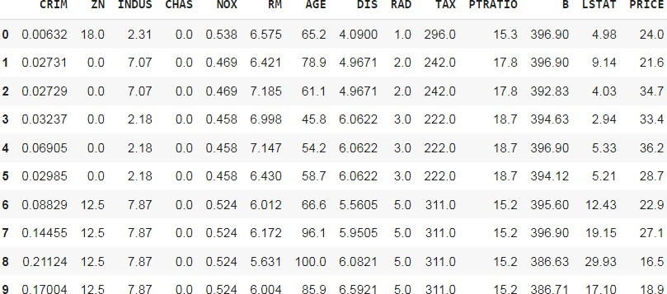

#Shape of the data print(data.shape)

#Checking the null values in the dataset data.isnull().sum()

|  |  |
| --- | --- |
| CRIM | 0 |
| ZN | 0 |
| INDUS | 0 |
| CHAS | 0 |
| NOX | 0 |
| RM | 0 |
| AGE | 0 |
| DIS | 0 |
| RAD | 0 |
| TAX | 0 |
| PTRATIO | 0 |
| B | 0 |
| LSTAT | 0 |
| PRICE | 0 |
| dtype: | int64 |

#Checking the statistics of the data data.describe()

# This is sometimes very useful, for example if you look at the CRIM the max is

88.97 and 75% of the value is below 3.677083 and

# mean is 3.613524 so it means the max values is actually an outlier or there are

outliers present in the column

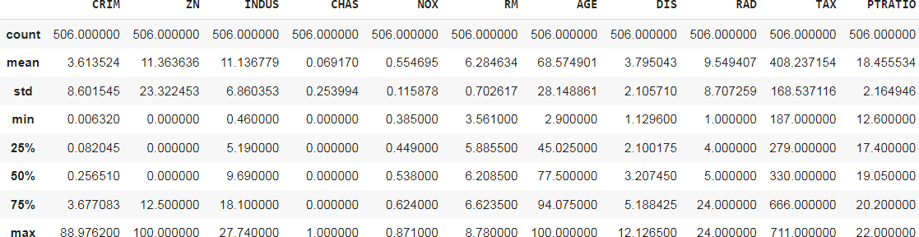

data.info()

<class 'pandas.core.frame.DataFrame'> RangeIndex: 506 entries, 0 to 505 Data columns (total 14 columns):

# Column Non-Null Count Dtype

|  |  |  |  |  |
| --- | --- | --- | --- | --- |
| 0 | CRIM | 506 | non-null | float64 |
| 1 | ZN | 506 | non-null | float64 |
| 2 | INDUS | 506 | non-null | float64 |
| 3 | CHAS | 506 | non-null | float64 |
| 4 | NOX | 506 | non-null | float64 |
| 5 | RM | 506 | non-null | float64 |
| 6 | AGE | 506 | non-null | float64 |
| 7 | DIS | 506 | non-null | float64 |
| 8 | RAD | 506 | non-null | float64 |
| 9 | TAX | 506 | non-null | float64 |
| 10 | PTRATIO | 506 | non-null | float64 |
| 11 | B | 506 | non-null | float64 |
| 12 | LSTAT | 506 | non-null | float64 |
| 13 | PRICE | 506 | non-null | float64 |

dtypes: float64(14) memory usage: 55.5 KB

#checking the distribution of the target variable import seaborn as sns

sns.distplot(data.PRICE)

#The distribution seems normal, has not be the data normal we would have perform log transformation or took to square root of the data to make the data normal.

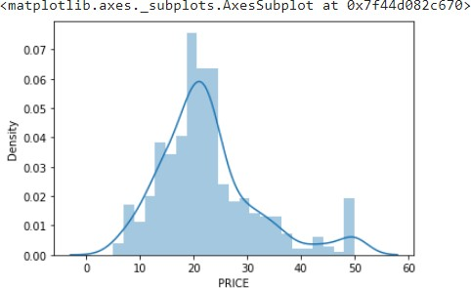# Normal distribution is need for the machine learning for better predictiblity of the model

#Distribution using box plot sns.boxplot(data.PRICE)

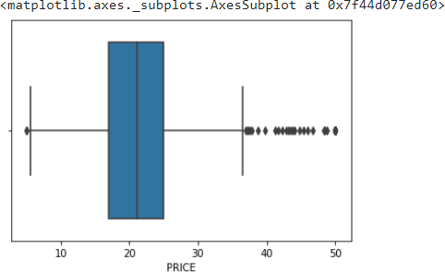

#Checking the correlation of the independent feature with the dependent feature # Correlation is a statistical technique that can show whether and how strongly pairs of variables are related.An intelligent correlation analysis can lead to a greater understanding of your data

#checking Correlation of the data correlation = data.corr() correlation.loc['PRICE']

CRIM -0.388305

|  |  |
| --- | --- |
| ZN | 0.360445 |
| INDUS | -0.483725 |
| CHAS | 0.175260 |
| NOX | -0.427321 |
| RM | 0.695360 |
| AGE | -0.376955 |
| DIS | 0.249929 |
| RAD | -0.381626 |
| TAX | -0.468536 |
| PTRATIO | -0.507787 |
| B | 0.333461 |
| LSTAT | -0.737663 |
| PRICE | 1.000000 |

Name: PRICE, dtype: float64 # plotting the heatmap

import matplotlib.pyplot as plt

fig,axes = plt.subplots(figsize=(15,12)) sns.heatmap(correlation,square = True,annot = True)

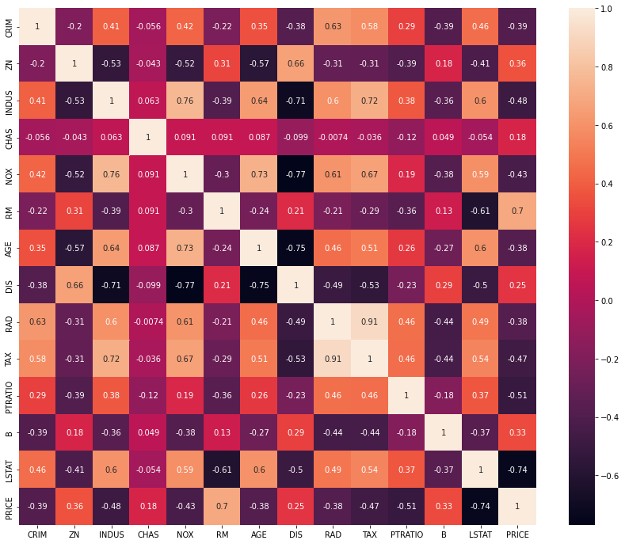# By looking at the correlation plot LSAT is negatively correlated with -0.75 and RM is positively correlated to the price and PTRATIO is correlated negatively with -0.51

# Checking the scatter plot with the most correlated features plt.figure(figsize = (20,5))

features = ['LSTAT','RM','PTRATIO']

for i, col in enumerate(features): plt.subplot(1, len(features) , i+1) x = data[col]

y = data.PRICE

plt.scatter(x, y, marker='o') plt.title("Variation in House prices") plt.xlabel(col)

plt.ylabel('"House prices in $1000"')

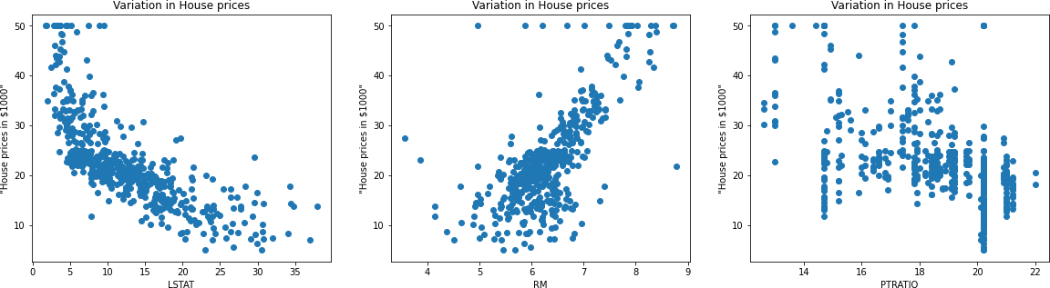

# Splitting the dependent feature and independent feature #X = data[['LSTAT','RM','PTRATIO']]

X = data.iloc[:,:-1] y= data.PRICE

# In order to provide a standardized input to our neural network, we need the perform the normalization of our dataset.

# This can be seen as an step to reduce the differences in scale that may arise from the existent features.

# We perform this normalization by subtracting the mean from our data and dividing it by the standard deviation.

# One more time, this normalization should only be performed by using the mean and standard deviation from the training set,

# in order to avoid any information leak from the test set.

mean = X_train.mean(axis=0) std = X_train.std(axis=0)

X_train = (X_train - mean) / std X_test = (X_test - mean) / std #Linear Regression

from sklearn.linear_model import LinearRegression

regressor = LinearRegression() #Fitting the model regressor.fit(X_train,y_train) # Model Evaluation

#Prediction on the test dataset y_pred = regressor.predict(X_test)

# Predicting RMSE the Test set results

from sklearn.metrics import mean_squared_error

rmse = (np.sqrt(mean_squared_error(y_test, y_pred))) print(rmse)

from sklearn.metrics import r2_score r2 = r2_score(y_test, y_pred) print(r2)

# Neural Networks #Scaling the dataset

from sklearn.preprocessing import StandardScaler sc = StandardScaler()

X_train = sc.fit_transform(X_train) X_test = sc.transform(X_test)

# Due to the small amount of presented data in this dataset, we must be careful to not create an overly complex model,

# which could lead to overfitting our data. For this, we are going to adopt an architecture based on two Dense layers,

# the first with 128 and the second with 64 neurons, both using a ReLU activation function.

# A dense layer with a linear activation will be used as output layer.

# In order to allow us to know if our model is properly learning, we will use a mean squared error loss function and to report the performance of it we will adopt the mean average error metric.

# By using the summary method from Keras, we can see that we have a total of 10,113 parameters, which is acceptable for us.

#Creating the neural network model import keras

from keras.layers import Dense, Activation,Dropout from keras.models import Sequential

model = Sequential()

model.add(Dense(128,activation = 'relu',input_dim =13)) model.add(Dense(64,activation = 'relu'))

model.add(Dense(32,activation = 'relu')) model.add(Dense(16,activation = 'relu')) model.add(Dense(1))

#model.compile(optimizer='adam', loss='mse', metrics=['mae']) model.compile(optimizer = 'adam',loss ='mean_squared_error',metrics=['mae'])

!pip install ann_visualizer

!pip install graphviz

from ann_visualizer.visualize import ann_viz; #Build your model here

ann_viz(model, title="DEMO ANN");

history = model.fit(X_train, y_train, epochs=100, validation_split=0.05)

# By plotting both loss and mean average error, we can see that our model was capable of learning patterns in our data without overfitting taking place (as shown by the validation set curves)

from plotly.subplots import make_subplots import plotly.graph_objects as go

fig = go.Figure() fig.add_trace(go.Scattergl(y=history.history['loss'],

name='Train'))

fig.add_trace(go.Scattergl(y=history.history['val_loss'],

name='Valid'))

fig.update_layout(height=500, width=700,

xaxis_title='Epoch', yaxis_title='Loss')

fig.show()

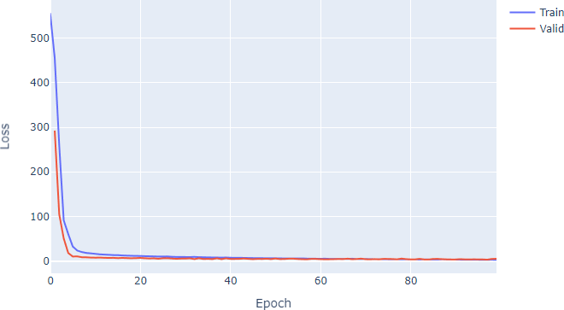

fig = go.Figure()

fig.add_trace(go.Scattergl(y=history.history['mae'],

name='Train'))

fig.add_trace(go.Scattergl(y=history.history['val_mae'],

name='Valid'))

fig.update_layout(height=500, width=700,

xaxis_title='Epoch', yaxis_title='Mean Absolute Error')

fig.show()

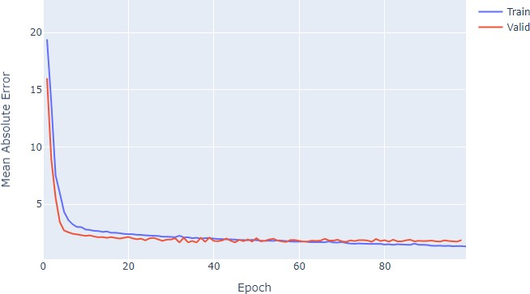

#Evaluation of the model y_pred = model.predict(X_test)

mse_nn, mae_nn = model.evaluate(X_test, y_test)

print('Mean squared error on test data: ', mse_nn) print('Mean absolute error on test data: ', mae_nn)

4/4 [==============================] - 0s 4ms/step - loss: 10.5717 - mae: 2.2670

Mean squared error on test data: 10.571733474731445 Mean absolute error on test data: 2.2669904232025146 #Comparison with traditional approaches

#First let's try with a simple algorithm, the Linear Regression:

from sklearn.metrics import mean_absolute_error

lr_model = LinearRegression() lr_model.fit(X_train, y_train)

y_pred_lr = lr_model.predict(X_test)

mse_lr = mean_squared_error(y_test, y_pred_lr) mae_lr = mean_absolute_error(y_test, y_pred_lr)

print('Mean squared error on test data: ', mse_lr) print('Mean absolute error on test data: ', mae_lr) from sklearn.metrics import r2_score

r2 = r2_score(y_test, y_pred) print(r2)

0.8812832788381159

# Predicting RMSE the Test set results

from sklearn.metrics import mean_squared_error

rmse = (np.sqrt(mean_squared_error(y_test, y_pred))) print(rmse)

3.320768607496587

# Make predictions on new data import sklearn

new_data = sklearn.preprocessing.StandardScaler().fit_transform(([[0.1, 10.0, 5.0, 0, 0.4, 6.0, 50, 6.0, 1, 400, 20, 300, 10]]))

prediction = model.predict(new_data) print("Predicted house price:", prediction)

1/1 [==============================] - 0s 70ms/step

Predicted house price: [[11.104753]]

#new_data =

sklearn.preprocessing.StandardScaler().fit_transform(([[0.1, 10.0,

5.0, 0, 0.4, 6.0, 50, 6.0, 1, 400, 20, 300, 10]])) is a line of code

that standardizes the input features of a new data point.

In this specific case, we have a new data point represented as a list of 13 numeric values ([0.1, 10.0, 5.0, 0, 0.4, 6.0, 50, 6.0, 1,

400, 20, 300, 10]) that represents the values for the 13 features of the Boston House Price dataset.

The StandardScaler() function from the sklearn.preprocessing module is used to standardize the data. Standardization scales each feature to have zero mean and unit variance, which is a common preprocessing step in machine learning to ensure that all features contribute equally to the model.

The fit_transform() method is used to fit the scaler to the data and apply the standardization transformation. The result is a new data

point with standardized feature values.

**Conclusion**- In this way we can Predict the Boston House Price using Deep Neural Network.

## Assignment Question

1. What is Linear Regression?
2. What is a Deep Neural Network?
3. What is the concept of standardization?
4. Why split data into train and test?
5. Write Down Application of Deep Neural Network?

# Group B Deep Learning Assignment No: 2A

**Title of the Assignment:** Binary classification using Deep Neural Networks Example: Classify movie reviews into positive" reviews and "negative" reviews, just based on the text content of the reviews.Use IMDB dataset

**Objective of the Assignment:** Students should be able to Classify movie reviews into positive reviews and "negative reviews on IMDB Dataset.

## Prerequisite:

1. Basic of programming language
2. Concept of Classification
3. Concept of Deep Neural Network

## ---------------------------------------------------------------------------------------------------------------

**Contents for Theory:**

1. What is Classification
2. Example of Classification
3. How Deep Neural Network Work on Classification
4. Code Explanation with Output

## ---------------------------------------------------------------------------------------------------------------

**What is Classification?**

Classification is a type of supervised learning in machine learning that involves categorizing data into predefined classes or categories based on a set of features or characteristics. It is used to predict the class of new, unseen data based on the patterns learned from the labeled training data.

In classification, a model is trained on a labeled dataset, where each data point has a known class label. The model learns to associate the input features with the corresponding class labels and can then be used to classify new, unseen data.

For example, we can use classification to identify whether an email is spam or not based on its content and metadata, to predict whether a patient has a disease based on their medical records and symptoms, or to classify images into different categories based on their visual features.

Classification algorithms can vary in complexity, ranging from simple models such as decision trees and k-nearest neighbors to more complex models such as support vector machines and neural networks. The choice of algorithm depends on the nature of the data, the size of the dataset, and the desired level of accuracy and interpretability.

Classification is a common task in deep neural networks, where the goal is to predict the class of an input based on its features. Here's an example of how classification can be performed in a deep neural network using the popular MNIST dataset of handwritten digits.

The MNIST dataset contains 60,000 training images and 10,000 testing images of handwritten digits from 0 to 9. Each image is a grayscale 28x28 pixel image, and the task is to classify each image into one of the 10 classes corresponding to the 10 digits.

We can use a convolutional neural network (CNN) to classify the MNIST dataset. A CNN is a type of deep neural network that is commonly used for image classification tasks.

## How Deep Neural Network Work on Classiﬁcation-

Deep neural networks are commonly used for classification tasks because they can automatically learn to extract relevant features from raw input data and map them to the correct output class.

The basic architecture of a deep neural network for classification consists of three main parts: an input layer, one or more hidden layers, and an output layer. The input layer receives the raw input data, which is usually preprocessed to a fixed size and format. The hidden layers are composed of neurons that apply linear transformations and nonlinear activations to the input features to extract relevant patterns and representations. Finally, the output layer produces the predicted class labels, usually as a probability distribution over the possible classes.

During training, the deep neural network learns to adjust its weights and biases in each layer to minimize the difference between the predicted output and the true labels. This is typically done by optimizing a loss function that measures the discrepancy between the predicted and true labels, using techniques such as gradient descent or stochastic gradient descent.

One of the key advantages of deep neural networks for classification is their ability to learn hierarchical representations of the input data. In a deep neural network with multiple hidden layers, each layer learns to capture more complex and abstract features than the previous layer, by building on the representations learned by the earlier layers. This hierarchical structure allows deep neural networks to learn highly discriminative features that can separate different classes of input data, even when the data is highly complex or noisy.

Overall, the effectiveness of deep neural networks for classification depends on the choice of architecture, hyperparameters, and training procedure, as well as the quality and quantity of the training data. When trained properly, deep neural networks can achieve state-of-the-art performance on a wide range of classification tasks, from image recognition to natural language processing.

**IMDB Dataset-**The IMDB dataset is a large collection of movie reviews collected from the IMDB website, which is a popular source of user-generated movie ratings and reviews. The dataset consists of 50,000 movie reviews, split into 25,000 reviews for training and 25,000 reviews for testing.

Each review is represented as a sequence of words, where each word is represented by an integer index based on its frequency in the dataset. The labels for each review are binary, with 0 indicating a negative review and 1 indicating a positive review.

The IMDB dataset is commonly used as a benchmark for sentiment analysis and text classification tasks, where the goal is to classify the movie reviews as either positive or negative based on their text content. The dataset is challenging because the reviews are often highly subjective and can contain complex language and nuances of meaning, making it difficult for traditional machine learning approaches to accurately classify them.

Deep learning approaches, such as deep neural networks, have achieved state-of-the-art performance on the IMDB dataset by automatically learning to extract relevant features from the raw text data and map them to the correct output class. The IMDB dataset is widely used in research and education for natural language processing and machine learning, as it provides a rich source of labeled text data for training and testing deep learning models.

## Source Code and Output-

# The IMDB sentiment classification dataset consists of 50,000 movie reviews from IMDB users that are labeled as either positive (1) or negative (0).

# The reviews are preprocessed and each one is encoded as a sequence of word indexes in the form of integers.

# The words within the reviews are indexed by their overall frequency within the dataset. For example, the integer “2” encodes the second most frequent word in the data.

# The 50,000 reviews are split into 25,000 for training and 25,000 for testing.

# Text Process word by word at diffrent timestamp ( You may use RNN LSTM GRU ) # convert input text to vector reprent input text

# DOMAIN: Digital content and entertainment industry

# CONTEXT: The objective of this project is to build a text classification model that analyses the customer's sentiments based on their reviews in the IMDB database. The model uses a complex deep learning model to build an embedding layer followed by a classification algorithm to analyse the sentiment of the customers.

# DATA DESCRIPTION: The Dataset of 50,000 movie reviews from IMDB, labelled by sentiment (positive/negative).

# Reviews have been preprocessed, and each review is encoded as a sequence of word indexes (integers).

# For convenience, the words are indexed by their frequency in the dataset, meaning the for that has index 1 is the most frequent word.

# Use the first 20 words from each review to speed up training, using a max vocabulary size of 10,000.

# As a convention, "0" does not stand for a specific word, but instead is used to encode any unknown word.

# PROJECT OBJECTIVE: Build a sequential NLP classifier which can use input text parameters to determine the customer sentiments.

import numpy as np import pandas as pd

from sklearn.model_selection import train_test_split #loading imdb data with most frequent 10000 words

from keras.datasets import imdb

(X_train, y_train), (X_test, y_test) = imdb.load_data(num_words=10000) # you may take top 10,000 word frequently used review of movies other are discarded

#consolidating data for EDA Exploratory data analysis (EDA) is used by data scientists to analyze and investigate data sets and summarize their main characteristics

data = np.concatenate((X_train, X_test), axis=0) # axis 0 is first running vertically downwards across rows (axis 0), axis 1 is second running horizontally across columns (axis 1),

label = np.concatenate((y_train, y_test), axis=0)

X_train.shape (25000,)

X_test.shape (25000,)

y_train.shape (25000,)

y_test.shape (25000,)

print("Review is ",X_train[0]) # series of no converted word to vocabulory associated with index print("Review is ",y_train[0])

Review is [1, 194, 1153, 194, 8255, 78, 228, 5, 6, 1463, 4369, 5012, 134, 26, 4, 715, 8, 118, 1634, 14,

394, 20, 13, 119, 954, 189, 102, 5, 207, 110, 3103, 21, 14, 69, 188, 8, 30, 23, 7, 4, 249, 126, 93, 4, 114,

9, 2300, 1523, 5, 647, 4, 116, 9, 35, 8163, 4, 229, 9, 340, 1322, 4, 118, 9, 4, 130, 4901, 19, 4, 1002, 5,

89, 29, 952, 46, 37, 4, 455, 9, 45, 43, 38, 1543, 1905, 398, 4, 1649, 26, 6853, 5, 163, 11, 3215, 2, 4,

1153, 9, 194, 775, 7, 8255, 2, 349, 2637, 148, 605, 2, 8003, 15, 123, 125, 68, 2, 6853, 15, 349, 165,

4362, 98, 5, 4, 228, 9, 43, 2, 1157, 15, 299, 120, 5, 120, 174, 11, 220, 175, 136, 50, 9, 4373, 228, 8255,

5, 2, 656, 245, 2350, 5, 4, 9837, 131, 152, 491, 18, 2, 32, 7464, 1212, 14, 9, 6, 371, 78, 22, 625, 64,

1382, 9, 8, 168, 145, 23, 4, 1690, 15, 16, 4, 1355, 5, 28, 6, 52, 154, 462, 33, 89, 78, 285, 16, 145, 95]

Review is 0

vocab=imdb.get_word_index() # Retrieve the word index file mapping words to indices print(vocab)

{'fawn': 34701, 'tsukino': 52006, 'nunnery': 52007, 'sonja': 16816, 'vani': 63951, 'woods': 1408, 'spiders':

16115,

y_train

array([1, 0, 0, ..., 0, 1, 0])

y_test

array([0, 1, 1, ..., 0, 0, 0])

# Function to perform relevant sequence adding on the data

# Now it is time to prepare our data. We will vectorize every review and fill it with zeros so that it

contains exactly 10000 numbers.

# That means we fill every review that is shorter than 500 with zeros.

# We do this because the biggest review is nearly that long and every input for our neural network needs to have the same size.

# We also transform the targets into floats.

# sequences is name of method the review less than 10000 we perform padding overthere # binary vectorization code:

# VECTORIZE as one cannot feed integers into a NN

# Encoding the integer sequences into a binary matrix - one hot encoder basically

# From integers representing words, at various lengths - to a normalized one hot encoded tensor (matrix) of 10k columns

def vectorize(sequences, dimension = 10000): # We will vectorize every review and fill it with zeros so that it contains exactly 10,000 numbers.

# Create an all-zero matrix of shape (len(sequences), dimension) results = np.zeros((len(sequences), dimension))

for i, sequence in enumerate(sequences): results[i, sequence] = 1

return results

# Now we split our data into a training and a testing set. # The training set will contain reviews and the testing set # # Set a VALIDATION set

test_x = data[:10000] test_y = label[:10000] train_x = data[10000:] train_y = label[10000:] test_x.shape

(10000,)

test_y.shape (10000,)

train_x.shape (40000,)

train_y.shape (40000,)

print("Categories:", np.unique(label))

print("Number of unique words:", len(np.unique(np.hstack(data))))

# The hstack() function is used to stack arrays in sequence horizontally (column wise). Categories: [0 1]

Number of unique words: 9998 length = [len(i) for i in data]

print("Average Review length:", np.mean(length)) print("Standard Deviation:", round(np.std(length)))

# The whole dataset contains 9998 unique words and the average review length is 234 words, with a standard deviation of 173 words.

Average Review length: 234.75892 Standard Deviation: 173

# If you look at the data you will realize it has been already pre-processed.

# All words have been mapped to integers and the integers represent the words sorted by their frequency. # This is very common in text analysis to represent a dataset like this.

# So 4 represents the 4th most used word, # 5 the 5th most used word and so on...

# The integer 1 is reserved for the start marker,

# the integer 2 for an unknown word and 0 for padding. # Let's look at a single training example:

print("Label:", label[0])

Label: 1

print("Label:", label[1])

Label: 0 print(data[0])

# Retrieves a dict mapping words to their index in the IMDB dataset. index = imdb.get_word_index() # word to index

# Create inverted index from a dictionary with document ids as keys and a list of terms as values for each document

reverse_index = dict([(value, key) for (key, value) in index.items()]) # id to word

decoded = " ".join( [reverse_index.get(i - 3, "#") for i in data[0]] )

# The indices are offset by 3 because 0, 1 and 2 are reserved indices for "padding", "start of sequence" and "unknown".

print(decoded)

# this film was just brilliant casting location scenery story direction everyone's really suited the part they

played and you could just imagine being there robert # is an amazing actor and now the same being director # father came from the same scottish island as myself so i loved the fact there was a real connection with this film the witty remarks throughout the film

#Adding sequence to data

# Vectorization is the process of converting textual data into numerical vectors and is a process that is usually applied once the text is cleaned.

data = vectorize(data)

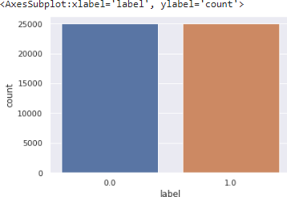label = np.array(label).astype("float32") labelDF=pd.DataFrame({'label':label}) sns.countplot(x='label', data=labelDF)

# Creating train and test data set

from sklearn.model_selection import train_test_split

X_train, X_test, y_train, y_test = train_test_split(data,label, test_size=0.20, random_state=1)

X_train.shape (40000, 10000)

X_test.shape (10000, 10000)

# Let's create sequential model

from keras.utils import to_categorical from keras import models

from keras import layers model = models.Sequential() # Input - Layer

# Note that we set the input-shape to 10,000 at the input-layer because our reviews are 10,000 integers long.

# The input-layer takes 10,000 as input and outputs it with a shape of 50. model.add(layers.Dense(50, activation = "relu", input_shape=(10000, )))

# Hidden - Layers

# Please note you should always use a dropout rate between 20% and 50%. # here in our case 0.3 means 30% dropout we are using dropout to prevent overfitting.

# By the way, if you want you can build a sentiment analysis without LSTMs, then you simply need to replace it by a flatten layer:

model.add(layers.Dropout(0.3, noise_shape=None, seed=None)) model.add(layers.Dense(50, activation = "relu")) model.add(layers.Dropout(0.2, noise_shape=None, seed=None)) model.add(layers.Dense(50, activation = "relu"))

# Output- Layer

model.add(layers.Dense(1, activation = "sigmoid")) model.summary()

Model: "sequential"

Layer (type) Output Shape Param #

=================================================================

|  |  |  |  |
| --- | --- | --- | --- |
| dense (Dense) | (None, | 50) | 500050 |
| dropout (Dropout) | (None, | 50) | 0 |
| dense_1 (Dense) | (None, | 50) | 2550 |
| dropout_1 (Dropout) | (None, | 50) | 0 |
| dense_2 (Dense) | (None, | 50) | 2550 |
| dense_3 (Dense) | (None, | 1) | 51 |

=================================================================

Total params: 505,201

Trainable params: 505,201

Non-trainable params: 0 #For early stopping

# Stop training when a monitored metric has stopped improving. # monitor: Quantity to be monitored.

# patience: Number of epochs with no improvement after which training will be stopped.

import tensorflow as tf

callback = tf.keras.callbacks.EarlyStopping(monitor='loss', patience=3)

# We use the “adam” optimizer, an algorithm that changes the weights and biases during training.

# We also choose binary-crossentropy as loss (because we deal with binary

classification) and accuracy as our evaluation metric.

model.compile( optimizer = "adam",

loss = "binary_crossentropy", metrics = ["accuracy"]

)

from sklearn.model_selection import train_test_split

results = model.fit( X_train, y_train, epochs= 2,

batch_size = 500,

validation_data = (X_test, y_test), callbacks=[callback]

)

# Let's check mean accuracy of our model print(np.mean(results.history["val_accuracy"])) # Evaluate the model

score = model.evaluate(X_test, y_test, batch_size=500) print('Test loss:', score[0])

print('Test accuracy:', score[1])

20/20 [==============================] - 1s 24ms/step - loss: 0.2511 - accuracy:

0.8986

Test loss: 0.25108325481414795

Test accuracy: 0.8985999822616577

#Let's plot training history of our model.

# list all data in history print(results.history.keys())

# summarize history for accuracy plt.plot(results.history['accuracy']) plt.plot(results.history['val_accuracy']) plt.title('model accuracy') plt.ylabel('accuracy') plt.xlabel('epoch')

plt.legend(['train', 'test'], loc='upper left') plt.show()

# summarize history for loss plt.plot(results.history['loss']) plt.plot(results.history['val_loss']) plt.title('model loss') plt.ylabel('loss')

plt.xlabel('epoch')

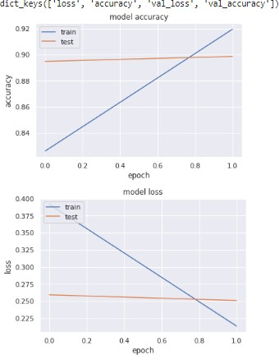plt.legend(['train', 'test'], loc='upper left') plt.show()

**Conclusion**- In this way we can Classify the Movie Reviews by using DNN.

## Assignment Question

* 1. What is Binary Classification?
  2. What is binary Cross Entropy?
  3. What is Validation Split?
  4. What is the Epoch Cycle?
  5. What is Adam Optimizer?

# Group B Deep Learning Assignment No: 2B

**Title of the Assignment:** Multiclass classification using Deep Neural Networks: Example: Use the OCR letter recognition dataset https://archive.ics.uci.edu/ml/datasets/letter+recognition

**Objective of the Assignment:** Students should be able to solve Multiclass classification using Deep Neural NetworksSolve

Prerequisite:

1. Basic of programming language
2. Concept of Multi Classification
3. Concept of Deep Neural Network

## ---------------------------------------------------------------------------------------------------------------

**Contents for Theory:**

1. What is Multi-Classification
2. Example of Multi-Classification
3. How Deep Neural Network Work on Multi-Classification
4. Code Explanation with Output

## ---------------------------------------------------------------------------------------------------------------

**What is multiclass classification ?**

Multi Classification, also known as multiclass classification or multiclass classification problem, is a type of classification problem where the goal is to assign input data to one of three or more classes or categories. In other words, instead of binary classification, where the goal is to assign input data to one of two classes (e.g., positive or negative), multiclass classification involves assigning input data to one of several possible classes or categories (e.g., animal species, types of products, etc.).

In multiclass classification, each input sample is associated with a single class label, and the goal of the model is to learn a function that can accurately predict the correct class label for new, unseen input data. Multiclass classification can be approached using a variety of machine learning algorithms, including decision trees, support vector machines, and deep neural networks.

Some examples of multiclass classification problems include image classification, where the goal is to classify images into one of several categories (e.g., animals, vehicles, buildings), and text classification, where the goal is to classify text documents into one of several categories (e.g., news topics, sentiment analysis).

## Example of multiclass classification-

Here are a few examples of multiclass classification problems:

**Image classification:** The goal is to classify images into one of several categories. For example, an image classification model might be trained to classify images of animals into categories such as cats, dogs, and birds.

**Text classification:** The goal is to classify text documents into one of several categories. For example, a text classification model might be trained to classify news articles into categories such as politics, sports, and entertainment.

**Disease diagnosis:** The goal is to diagnose patients with one of several diseases based on their symptoms and medical history. For example, a disease diagnosis model might be trained to classify patients into categories such as diabetes, cancer, and heart disease.

**Speech recognition:** The goal is to transcribe spoken words into text. A speech recognition model might be trained to recognize spoken words in several languages or dialects.

**Credit risk analysis:** The goal is to classify loan applicants into categories such as low risk, medium risk, and high risk. A credit risk analysis model might be trained to classify loan applicants based on their credit score, income, and other factors.

In all of these examples, the goal is to assign input data to one of several possible classes or categories.

Multiclass classification is a common task in machine learning and can be approached using a variety of algorithms, including decision trees, support vector machines, and deep neural networks.

**Source Code and Output**

import numpy as np

from tensorflow.keras.models import Sequential from tensorflow.keras.layers import Dense, Dropout from tensorflow.keras.optimizers import RMSprop from tensorflow.keras.datasets import mnist

import matplotlib.pyplot as plt from sklearn import metrics

# Load the OCR dataset

# The MNIST dataset is a built-in dataset provided by Keras.

# It consists of 70,000 28x28 grayscale images, each of which displays a single handwritten digit from 0 to 9.

# The training set consists of 60,000 images, while the test set has 10,000 images. (x_train, y_train), (x_test, y_test) = mnist.load_data()

# X_train and X_test are our array of images while y_train and y_test are our array of labels for each image.

# The first tuple contains the training set features (X_train) and the training set labels (y_train). # The second tuple contains the testing set features (X_test) and the testing set labels (y_test). # For example, if the image shows a handwritten 7, then the label will be the intger 7.

plt.imshow(x_train[0], cmap='gray') # imshow() function which simply displays an image.

plt.show() # cmap is responsible for mapping a specific colormap to the values found in the array that you passed as the first argument.

# This is because of the format that all the images in the dataset have:

# 1. All the images are grayscale, meaning they only contain black, white and grey. # 2. The images are 28 pixels by 25 pixels in size (28x28).

print(x_train[0])

# image data is just an array of digits. You can almost make out a 5 from the pattern of the digits in the array.

# Array of 28 values

# a grayscale pixel is stored as a digit between 0 and 255 where 0 is black, 255 is white and values in between are different shades of gray.

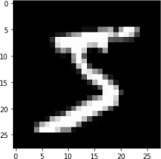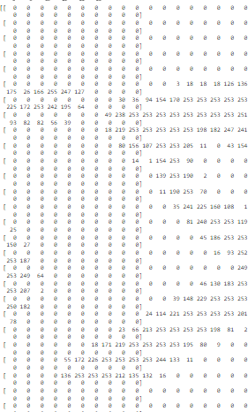# Therefore, each value in the [28][28] array tells the computer which color to put in that position when.

# reformat our X_train array and our X_test array because they do not have the correct shape. # Reshape the data to fit the model

print("X_train shape", x_train.shape) print("y_train shape", y_train.shape) print("X_test shape", x_test.shape) print("y_test shape", y_test.shape)

# Here you can see that for the training sets we have 60,000 elements and the testing sets have 10,000 elements.

# y_train and y_test only have 1 dimensional shapes because they are just the labels of each element.

# x_train and x_test have 3 dimensional shapes because they have a width and height (28x28 pixels) for each element.

# (60000, 28, 28) 1st parameter in the tuple shows us how much image we have 2nd and 3rd parameters are the pixel values from x to y (28x28)

# The pixel value varies between 0 to 255.

# (60000,) Training labels with integers from 0-9 with dtype of uint8. It has the shape (60000,).

# (10000, 28, 28) Testing data that consists of grayscale images. It has the shape (10000, 28, 28) and the dtype of uint8. The pixel value varies between 0 to 255.

# (10000,) Testing labels that consist of integers from 0-9 with dtype uint8. It has the shape (10000,). X_train shape (60000, 28, 28)

y_train shape (60000,)

X_test shape (10000, 28, 28)

y_test shape (10000,)

# X: Training data of shape (n_samples, n_features)

# y: Training label values of shape (n_samples, n_labels)

# 2D array of height and width, 28 pixels by 28 pixels will just become 784 pixels (28 squared).

# Remember that X_train has 60,000 elemenets, each with 784 total pixels so will become shape (60000, 784).

# Whereas X_test has 10,000 elements, each with each with 784 total pixels so will become shape (10000, 784).

x_train = x_train.reshape(60000, 784) x_test = x_test.reshape(10000, 784)

x_train = x_train.astype('float32') # use 32-bit precision when training a neural network, so at one point the training data will have to be converted to 32 bit floats. Since the dataset fits easily in RAM, we might as well convert to float immediately.

x_test = x_test.astype('float32')

x_train /= 255 # Each image has Intensity from 0 to 255 x_test /= 255

# Regarding the division by 255, this is the maximum value of a byte (the input feature's type before the conversion to float32),

# so this will ensure that the input features are scaled between 0.0 and 1.0. # Convert class vectors to binary class matrices

num_classes = 10

y_train = np.eye(num_classes)[y_train] # Return a 2-D array with ones on the diagonal and zeros elsewhere.

y_test = np.eye(num_classes)[y_test] # f your particular categories is present then it mark as 1 else 0 in remain row

# Define the model architecture model = Sequential()

model.add(Dense(512, activation='relu', input_shape=(784,))) # Input cosist of 784 Neuron ie 784 input, 512 in the hidden layer

model.add(Dropout(0.2)) # DROP OUT RATIO 20%

model.add(Dense(512, activation='relu')) #returns a sequence of another vectors of dimension 512 model.add(Dropout(0.2))

model.add(Dense(num_classes, activation='softmax')) # 10 neurons ie output node in the output layer. # Compile the model

model.compile(loss='categorical_crossentropy', # for a multi-class classification problem optimizer=RMSprop(),

metrics=['accuracy']) # Train the model

batch_size = 128 # batch_size argument is passed to the layer to define a batch size for the inputs. epochs = 20

history = model.fit(x_train, y_train,

batch_size=batch_size, epochs=epochs,

verbose=1, # verbose=1 will show you an animated progress bar eg. [==========] validation_data=(x_test, y_test)) # Using validation_data means you are providing the

training set and validation set yourself, # 60000image/128=469 batch each

# Evaluate the model

score = model.evaluate(x_test, y_test, verbose=0) print('Test loss:', score[0])

print('Test accuracy:', score[1]) Test loss: 0.08541901409626007

Test accuracy: 0.9851999878883362

**Conclusion**- In this way we can do Multi classification using DNN.

## Assignment Question

* 1. What is Batch Size?
  2. What is Dropout?
  3. What is RMSprop?
  4. What is the Softmax Function?
  5. What is the Relu Function?

|  |  |  |  |  |  |
| --- | --- | --- | --- | --- | --- |
| **Answers** | **Coding Efﬁciency** | **Viva** | **Timely Completion** | **Total** | **Dated Sign of Subject Teacher** |
| **5** | **5** | **5** | **5** | **20** |  |
|  |  |  |  |  |

Start Date :...................... Date of Completion:.......................

# Group B Deep Learning Assignment No: 3B

**Title of the Assignment:** Use MNIST Fashion Dataset and create a classifier to classify fashion clothing into categories.

**Objective of the Assignment:** Students should be able to Classify movie reviews into positive reviews and "negative reviews on IMDB Dataset.

## Prerequisite:

1. Basic of programming language
2. Concept of Classification
3. Concept of Deep Neural Network

## ---------------------------------------------------------------------------------------------------------------

**Contents for Theory:**

1. What is Classification
2. Example of Classification
3. What is CNN?
4. How Deep Neural Network Work on Classification
5. Code Explanation with Output

## ---------------------------------------------------------------------------------------------------------------

**What is Classification?**

Classification is a type of supervised learning in machine learning that involves categorizing data into predefined classes or categories based on a set of features or characteristics. It is used to predict the class of new, unseen data based on the patterns learned from the labeled training data.

In classification, a model is trained on a labeled dataset, where each data point has a known class label. The model learns to associate the input features with the corresponding class labels and can then be used to classify new, unseen data.

For example, we can use classification to identify whether an email is spam or not based on its content and metadata, to predict whether a patient has a disease based on their medical records and symptoms, or to classify images into different categories based on their visual features.

Classification algorithms can vary in complexity, ranging from simple models such as decision trees and k-nearest neighbors to more complex models such as support vector machines and neural networks. The choice of algorithm depends on the nature of the data, the size of the dataset, and the desired level of accuracy and interpretability.

**Example-** Classification is a common task in deep neural networks, where the goal is to predict the class of an input based on its features. Here's an example of how classification can be performed in a deep neural network using the popular MNIST dataset of handwritten digits.

The MNIST dataset contains 60,000 training images and 10,000 testing images of handwritten digits from 0 to 9. Each image is a grayscale 28x28 pixel image, and the task is to classify each image into one of the 10 classes corresponding to the 10 digits.

We can use a convolutional neural network (CNN) to classify the MNIST dataset. A CNN is a type of deep neural network that is commonly used for image classification tasks.

## What us CNN-

Convolutional Neural Networks (CNNs) are commonly used for image classification tasks, and they are designed to automatically learn and extract features from input images. Let's consider an example of using a CNN to classify images of handwritten digits.

In a typical CNN architecture for image classification, there are several layers, including convolutional layers, pooling layers, and fully connected layers. Here's a diagram of a simple CNN architecture for the digit classification task:

The input to the network is an image of size 28x28 pixels, and the output is a probability distribution over the 10 possible digits (0 to 9).

The convolutional layers in the CNN apply filters to the input image, looking for specific patterns and features. Each filter produces a feature map that highlights areas of the image that match the filter. The filters are learned during training, so the network can automatically learn which features are most relevant for the classification task.

The pooling layers in the CNN downsample the feature maps, reducing the spatial dimensions of the data. This helps to reduce the number of parameters in the network, while also making the features more robust to small variations in the input image.

The fully connected layers in the CNN take the flattened output from the last pooling layer and perform a classification task by outputting a probability distribution over the 10 possible digits.

During training, the network learns the optimal values of the filters and parameters by minimizing a loss function. This is typically done using stochastic gradient descent or a similar optimization algorithm.

Once trained, the network can be used to classify new images by passing them through the network and computing the output probability distribution.

Overall, CNNs are powerful tools for image recognition tasks and have been used successfully in many applications, including object detection, face recognition, and medical image analysis.

CNNs have a wide range of applications in various fields, some of which are:

**Image classification:** CNNs are commonly used for image classification tasks, such as identifying objects in images and recognizing faces.

**Object detection:** CNNs can be used for object detection in images and videos, which involves identifying the location of objects in an image and drawing bounding boxes around them.

**Semantic segmentation:** CNNs can be used for semantic segmentation, which involves partitioning an image into segments and assigning each segment a semantic label (e.g., "road", "sky", "building").

**Natural language processing:** CNNs can be used for natural language processing tasks, such as sentiment analysis and text classification.

**Medical imaging:** CNNs are used in medical imaging for tasks such as diagnosing diseases from X-rays and identifying tumors from MRI scans.

**Autonomous vehicles:** CNNs are used in autonomous vehicles for tasks such as object detection and lane detection.

**Video analysis:** CNNs can be used for tasks such as video classification, action recognition, and video captioning.

Overall, CNNs are a powerful tool for a wide range of applications, and they have been used successfully in many areas of research and industry.

## How Deep Neural Network Work on Classiﬁcation using CNN-

Deep neural networks using CNNs work on classification tasks by learning to automatically extract features from input images and using those features to make predictions. Here's how it works:

Input layer: The input layer of the network takes in the image data as input.

Convolutional layers: The convolutional layers apply filters to the input images to extract relevant features. Each filter produces a feature map that highlights areas of the image that match the filter.

Activation functions: An activation function is applied to the output of each convolutional layer to introduce non-linearity into the network.

Pooling layers: The pooling layers downsample the feature maps to reduce the spatial dimensions of the data.

Dropout layer: Dropout is used to prevent overfitting by randomly dropping out a percentage of the neurons in the network during training.

Fully connected layers: The fully connected layers take the flattened output from the last pooling layer and perform a classification task by outputting a probability distribution over the possible classes.

Softmax activation function: The softmax activation function is applied to the output of the last fully connected layer to produce a probability distribution over the possible classes.

Loss function: A loss function is used to compute the difference between the predicted probabilities and the actual labels.

Optimization: An optimization algorithm, such as stochastic gradient descent, is used to minimize the loss function by adjusting the values of the network parameters.

Training: The network is trained on a large dataset of labeled images, adjusting the values of the parameters to minimize the loss function.

Prediction: Once trained, the network can be used to classify new images by passing them through the network and computing the output probability distribution.

## MNIST Dataset-

The MNIST Fashion dataset is a collection of 70,000 grayscale images of 28x28 pixels, representing 10 different categories of clothing and accessories. The categories include T-shirts/tops, trousers, pullovers, dresses, coats, sandals, shirts, sneakers, bags, and ankle boots.

The dataset is often used as a benchmark for testing image classification algorithms, and it is considered a more challenging version of the original MNIST dataset which contains handwritten digits. The

MNIST Fashion dataset was released by Zalando Research in 2017 and has since become a popular dataset in the machine learning community.

he MNIST Fashion dataset is a collection of 70,000 grayscale images of 28x28 pixels each. These images represent 10 different categories of clothing and accessories, with each category containing 7,000 images. The categories are as follows:

T-shirt/tops Trousers Pullovers Dresses Coats Sandals Shirts Sneakers Bags

Ankle boots

The images were obtained from Zalando's online store and are preprocessed to be normalized and centered. The training set contains 60,000 images, while the test set contains 10,000 images. The goal of the dataset is to accurately classify the images into their respective categories.

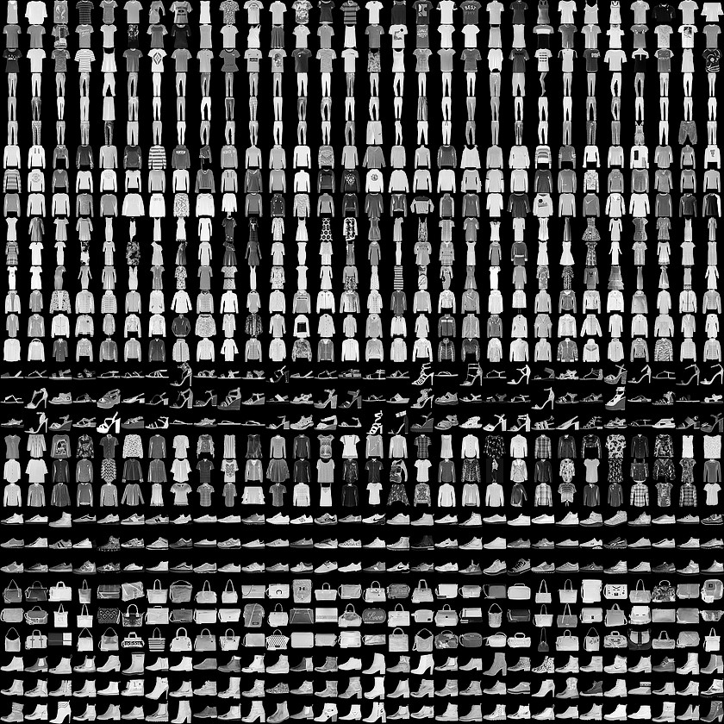The MNIST Fashion dataset is often used as a benchmark for testing image classification algorithms, and it is considered a more challenging version of the original MNIST dataset which contains handwritten digits. The dataset is widely used in the machine learning community for research and educational purposes.

Here are the general steps to perform Convolutional Neural Network (CNN) on the MNIST Fashion dataset:

* Import the necessary libraries, including TensorFlow, Keras, NumPy, and Matplotlib.
* Load the dataset using Keras' built-in function, keras.datasets.fashion_mnist.load_data(). This will provide the training and testing sets, which will be used to train and evaluate the CNN.
* Preprocess the data by normalizing the pixel values between 0 and 1, and reshaping the images to be of size (28, 28, 1) for compatibility with the CNN.
* Define the CNN architecture, including the number and size of filters, activation functions, and pooling layers. This can vary based on the specific problem being addressed.
* Compile the model by specifying the loss function, optimizer, and evaluation metrics. Common choices include categorical cross-entropy, Adam optimizer, and accuracy metric.
* Train the CNN on the training set using the fit() function, specifying the number of epochs and batch size.
* Evaluate the performance of the model on the testing set using the evaluate() function. This will provide metrics such as accuracy and loss on the test set.
* Use the trained model to make predictions on new images, if desired, using the predict() function.

## Source Code with Output-

import tensorflow as tf

import matplotlib.pyplot as plt from tensorflow import keras import numpy as np

(x_train, y_train), (x_test, y_test) = keras.datasets.fashion_mnist.load_data()

# There are 10 image classes in this dataset and each class has a mapping corresponding to the following labels:

#0 T-shirt/top #1 Trouser

#2 pullover

#3 Dress

#4 Coat

#5 sandals

#6 shirt

#7 sneaker

#8 bag

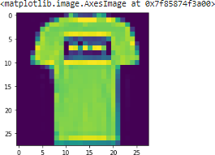#9 ankle boot plt.imshow(x_train[1])

plt.imshow(x_train[0])

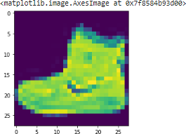

# Next, we will preprocess the data by scaling the pixel values to be between 0 and 1, and then reshaping the images to be 28x28 pixels.

x_train = x_train.astype('float32') / 255.0 x_test = x_test.astype('float32') / 255.0

x_train = x_train.reshape(-1, 28, 28, 1)

x_test = x_test.reshape(-1, 28, 28, 1)

# 28, 28 comes from width, height, 1 comes from the number of channels # -1 means that the length in that dimension is inferred.

# This is done based on the constraint that the number of elements in an ndarray or Tensor when reshaped must remain the same.

# each image is a row vector (784 elements) and there are lots of such rows (let it be n, so there are 784n elements). So TensorFlow can infer that -1 is n.

# converting the training_images array to 4 dimensional array with sizes 60000, 28, 28, 1 for 0th to 3rd dimension.

x_train.shape (60000, 28, 28)

x_test.shape (10000, 28, 28, 1)

y_train.shape (60000,)

y_test.shape (10000,)

# We will use a convolutional neural network (CNN) to classify the fashion items. # The CNN will consist of multiple convolutional layers followed by max pooling, # dropout, and dense layers. Here is the code for the model:

model = keras.Sequential([

keras.layers.Conv2D(32, (3,3), activation='relu', input_shape=(28,28,1)), # 32 filters (default), randomly initialized

# 3*3 is Size of Filter

# 28,28,1 size of Input Image

# No zero-padding: every output 2 pixels less in every dimension

# in Paramter shwon 320 is value of weights: (3x3 filter weights + 32 bias) * 32 filters # 32*3*3=288(Total)+32(bias)= 320

keras.layers.MaxPooling2D((2,2)),

# It shown 13 * 13 size image with 32 channel or filter or depth. keras.layers.Dropout(0.25),

# Reduce Overfitting of Training sample drop out 25% Neuron keras.layers.Conv2D(64, (3,3), activation='relu'),

# Deeper layers use 64 filters # 3*3 is Size of Filter

# Observe how the input image on 28x28x1 is transformed to a 3x3x64 feature map

# 13(Size)-3(Filter Size )+1(bias)=11 Size for Width and Height with 64 Depth or filtter or channel # in Paramter shwon 18496 is value of weights: (3x3 filter weights + 64 bias) * 64 filters

# 64*3*3=576+1=577*32 + 32(bias)=18496

keras.layers.MaxPooling2D((2,2)),

# It shown 5 * 5 size image with 64 channel or filter or depth. keras.layers.Dropout(0.25),

keras.layers.Conv2D(128, (3,3), activation='relu'), # Deeper layers use 128 filters

# 3*3 is Size of Filter

# Observe how the input image on 28x28x1 is transformed to a 3x3x128 feature map

# It show 5(Size)-3(Filter Size )+1(bias)=3 Size for Width and Height with 64 Depth or filtter or channel

# 128*3*3=1152+1=1153*64 + 64(bias)= 73856

# To classify the images, we still need a Dense and Softmax layer.

# We need to flatten the 3x3x128 feature map to a vector of size 1152 keras.layers.Flatten(),

keras.layers.Dense(128, activation='relu'), # 128 Size of Node in Dense Layer

# 1152*128 = 147584

keras.layers.Dropout(0.25), keras.layers.Dense(10, activation='softmax') # 10 Size of Node another Dense Layer

# 128*10+10 bias= 1290

])

model.summary() Model: "sequential"

Layer (type) Output Shape Param #

=================================================================

conv2d (Conv2D) (None, 26, 26, 32) 320

max_pooling2d (MaxPooling2D (None, 13, 13, 32) 0

)

dropout (Dropout) (None, 13, 13, 32) 0

conv2d_1 (Conv2D) (None, 11, 11, 64) 18496

max_pooling2d_1 (MaxPooling (None, 5, 5, 64) 0

2D)

dropout_1 (Dropout) (None, 5, 5, 64) 0

|  |  |  |
| --- | --- | --- |
| conv2d_2 (Conv2D) | (None, 3, 3, 128) | 73856 |
| flatten (Flatten) | (None, 1152) | 0 |
| dense (Dense) | (None, 128) | 147584 |
| dropout_2 (Dropout) | (None, 128) | 0 |
| dense_1 (Dense) | (None, 10) | 1290 |

=================================================================

Total params: 241,546

Trainable params: 241,546

Non-trainable params: 0

# Compile and Train the Model

# After defining the model, we will compile it and train it on the training data. model.compile(optimizer='adam', loss='sparse_categorical_crossentropy', metrics=['accuracy']) history = model.fit(x_train, y_train, epochs=10, validation_data=(x_test, y_test))

# 1875 is a number of batches. By default batches contain 32 samles.60000 / 32 = 1875 # Finally, we will evaluate the performance of the model on the test data.

test_loss, test_acc = model.evaluate(x_test, y_test) print('Test accuracy:', test_acc)

313/313 [==============================] - 3s 10ms/step - loss: 0.2606 - accuracy: 0.9031

Test accuracy: 0.9031000137329102

**Conclusion**- In this way we can Classify fashion clothing into categories using CNN.

## Assignment Question

* 1. What is Binary Classification?
  2. What is binary Cross Entropy?
  3. What is Validation Split?
  4. What is the Epoch Cycle?
  5. What is Adam Optimizer?